**ALAGAPPA COLLEGE OF TECHNOLOGY**

**ANNA UNIVERSITY-600025**

**Zone:**

Zone-I

**Department:**

B.Tech-Pharmaceutical technology

**Details:**

|  |  |  |
| --- | --- | --- |
| **Student Name** | **Roll no.** | **Naan mudhalvan ID** |
| Gowtham R | 2020308010 | 204A63937B086B2A80347E80A78A34A7 |

--------------------------------------------------------------

**Brand Name:** Petal Picks

**Category:** Shopping

**Email:** [petallpicks@gmail.com](mailto:petallpicks@gmail.com)

**Blog address:** <https://petallpicks.blogspot.com/>

**Google analytics tracking code:** G-VWFC80MYJY

**1.)Create a blog or website using Blogspot and WordPress. Customize the theme design and post new article with 500 Words.**

Url: <https://petallpicks.blogspot.com/>

Blog:

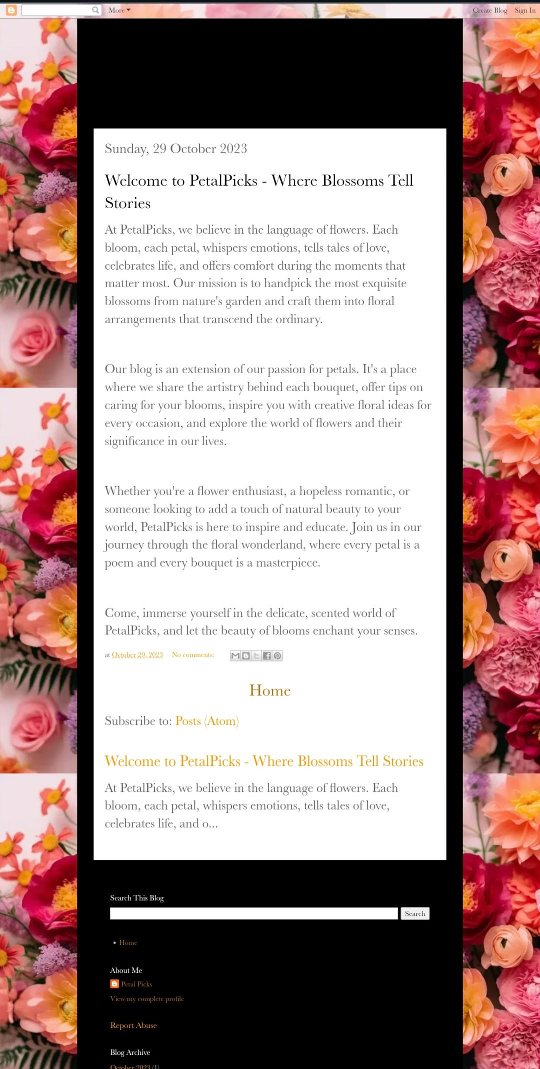

**2.) Create a New Facebook Business Page and post one Social media poster for your brand.**

Url: <https://www.facebook.com/profile.php?id=61552591665718>

Logo:



**3.) Create and design a social media advertisement poster using canva.**



**4.) Create email newsletter design using MailChimp or canva Tool.**

Url: <https://petallpicks.blogspot.com/2023/10/email-newsletter.html>

Email newsletter design: